SP2 SCOPES Project for Speech Prosody
Recommendations for Recording and Annotation of a Multilingual Database Containing Prosodically Rich Sentences
Version 1.6

- Introduction
This document describes the requirements for recording and annotation of a multilingual database containing prosodically rich sentences. For each particular language, an individual or organization (referred to as party) will be in charge of recording and annotating a section of a database, and this individual or organization is not necessarily an SP2 project partner or a member of a partner organization in SP2.

- Contents of the corpus and its storage
The entire corpus, including text and audio files, will be stored in the SP2 Dropbox folder (https://www.dropbox.com/home/SCOPES) during its preparation, more precisely, in its Corpus subfolder.
The text will be jointly stored in the XLS file SP2 Parallel Prosody Corpus.xls in the Corpus folder, with datasheets corresponding to particular languages.
Audio files will be stored in appropriate subfolders of the Corpus folder, corresponding to particular languages. If more than one speaker per language is employed (which is desirable, but not mandatory), there should be a subfolder for each speaker (e.g. SCOPES/Corpus/Audio/English/John and SCOPES/Corpus/Audio/English/Mary).

- Tasks
3.1. Translation
Since each party (for each language) will deal with sentences with textual content corresponding to the content in English available in the XLS file SP2 Parallel Prosody Corpus.xls (and in the Appendix of this document), the first task is the translation of this content into the target language.
In the translated content, the emphasized word(s) should be marked in bold. The translator should try to preserve the original meaning of the sentence, but more importantly, to preserve the emphasis in the translation (to avoid e.g. signaling emphasis by a particular choice of words instead).
The translations should be stored in the MS Excel file SP2 Parallel Prosody Corpus.xls, in the datasheet corresponding to the target language (see examples for languages already covered).

3.2. Recording
The recordings should be done by a single speaker, male or female. If more than one speaker is included in the corpus preparation (which is desirable but not mandatory), Tasks 3.2. and 3.3. should be repeated for each speaker.
The text corpus contains 50 sentences and the speaker should deliver:
- 50 utterances with particular emphasis on the words or parts of sentences marked in bold,
- the same 50 utterances without particular emphasis on the marked word or parts of sentences, to the degree to which it is reasonably possible. (Note that e.g. in Sections C and D, dealing with contrastive focus, it can be rather difficult to pronounce a particular sentence without emphasis, as emphasis „comes naturally“.)
The speaker should, thus, deliver a total of 100 utterances.
It is desirable that the speaker delivers the neutral and the emphasized version of a particular utterance immediately one after another, rather than deliver a group of sentences without emphases and then a group of sentences with them. This will contribute to the uniformity of speech register, speech tempo, as well as overall voice quality within pairs of utterances with the same content.
The recordings should be done in a quiet room, avoiding external or internal noise. A professional equipment and studio are preferable, but not mandatory. A relatively quiet laptop with a microphone of reasonable quality should be sufficient.
The utterances should be recorded as individual wav files (mono, linear 16-bit encoding, sampling rate 48 kHz), stored in a particular language folder and speaker subfolder in the SCOPES Corpus folder (an example of a path is SCOPES/Corpus/Audio/Macedonian/agjoreski/wavs), and named according to the following scheme:
<filename> ::= <corpus-segment-code-A-to-E> <utterance-number-01-to-10> <emphasis-E> ".wav"
| <corpus-segment-code-A-to-E> <utterance-number-01-to-10> ".wav"
For example, the recording of the sentence A05 with emphasis, should be named A05E.wav, while the recording of the same sentence without emphasis should be named A05.wav.

3.3. Annotation
Annotation should be done in Praat, and the annotation should have the form of a Praat TextGrid file, with the following interval tiers included (Praat tier names are given in brackets):
Interval tiers
Mandatory: Tier 1 – Emphasis (“emphasis”)
A word-level tier, where only the emphasized word(s) are marked with ‘+’, while other words are not marked. In the text corpus there are no sentences which require extra strong emphasis, however, if the word is pronounced as emphasized unusually strongly, the labeller should be free to assign a ‘++’ sign. Note that this does not mean that all words marked in bold in the text must get a ‘+’ or ‘++’, e.g., if the emphasized constituent is heavy, not all words will actually be emphasized, as in the example “Only on the race track are we allowed to run” (here only the word “race” is regularly stressed). The bold marking is used merely to suggest that this utterance might have been elicited by a question such as “What is the only place where we are allowed to run?”. However, the words that are not explicitly marked in bold should not be assigned a ‘+’ or ‘++’ tag.
If a word is marked with ’+’ or ’++’ in the emphasized utterance, there should be a corresponding ’(+)’ or ’(++)’ sign in the neutral utterance, marking the absence of emphasis, but nevertheless, indicating the position of the corresponding word in the neutral utterance. The sequences of ‘+’ and ‘++’ tags in the emphasized utterance and the ‘(+)’ and ‘(++)’ tags in the neutral utterance should thus match (e.g., if the emphasized utterance contains a single ‘++’, the neutral utterance should contain a single ‘(++)’ at the corresponding word.)
Optional: Tier 2 – Contrastive emphasis (“contrast”)
This is a semantic tier, which, in sentences with contrastive emphasis (sections C and D), marks the opposing elements indicated in bold in the text (e.g. “Instead of getting a rest, I got tired”). Here, words in contrast (“rest” and “tired”) should be marked with ‘1’ and ‘2’ respectively, similarly as in Tier 1. In some cases, where more than one word is emphasized on either of the opposing sides, multiple ‘1’ or ‘2’ tags should be assigned. If a word is marked with a ‘1’ or ‘2’ in the emphasized utterance, it has to be assigned the same tag in the non-emphasized utterance, regardless of the fact that it is may not be actually emphasized there.
Tier 3 – Words (“words”)
This tier indicates word boundaries. Words should be given in their orthographic forms, for an easier match with the text.
Tier 4 – Syllables (“syllables”)
This tier indicates syllable boundaries. Syllables should be given in their orthographic forms.
Tier 5 – Lexical stress (“lexstress”)
This tier marks lexically stressed syllables with a ‘+’. In case speaker put the stress on a different syllable than in the standard pronunciation, a syllable actually stressed should be indicated (in general, at least for some languages and particular words, there can be more than one acceptable location of the lexical stress).
Tier 6 – Lexical tone (“lextone”)
Applicable only to languages with pitch accent (in context of SP2 project, at present only to Serbian). This tier indicates the tone of the particular syllable (‘H’ or ‘L’), in order to describe the falling and the rising lexical pitch accent in a compact way.
Tier 7 – Phones (“phones”)
This tier indicates phone boundaries and gives a phonetic transcription in SAMPA format. The purpose of this tier is to enable a more detailed analysis of f0 contours, since stress is primarily related to the vowel in the syllable.
Point tiers
Optional: Tier 8 – Phrase breaks (“breaks”)
This tier indicates the positions of phrase breaks which significantly affect pitch in either of the two versions of the uttearnce. The purpose of this tier is to indicate possible sources of major pitch variations which are not due to emphasis. Such breaks should be indicated by ‘B’ in both versions of the utterance even if their impact is significant in only one of them.
Example 1
The following example (Fig. 1) shows the full annotation of the following Macedonian sentence (version with emphasis): “Сите мислеа дека тој знаел за заговорот.” (Everybody thought that he knew about the plot.). In this example the orthographic form is given in Latin letters for convenience.
The contrastive stress is not marked, as there is none in this example. Similarly, lexical tones are not applicable to Macedonian, so Tier 6 is empty. There are no relevant phrase breaks so Tier 8 is empty as well.
Grapheme-to-phoneme correspondence appears to be 1-to-1, since SAMPA notation of all phonemes in this example is identical to their orthographic form. Note, however, that this is not the case for all Macedonian phonemes.
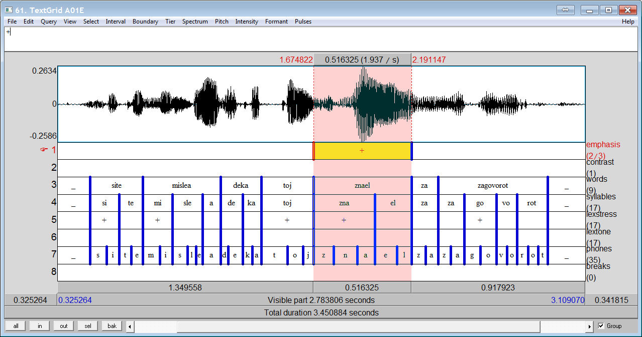
Figure 1. Annotation of an emphasized sentence in Macedonian. In the corresponding non-emphasized sentence, the absence of emphasis would be indicated by a ‘(+)’ marker on the emphasis tier, positioned at the corresponding word (‘znael’)
Example 2
This example (Fig. 2) shows the full annotation of the following Serbian sentence (version without emphasis): “Sejšeli nisu jedno ostrvo, već čine grupaciju od sto petnaest ostrva.” (Seychelles are not a single island but a group of one hundred and fifteen islands.).
Since this is the non-emphasized version of the utterance, absence of emphasis is marked on the words that are emphasized in the corresponding emphasized utterance. Since in the emphasized version all of them are indicated by ‘+’ (and not ‘++’), the absence of emphasis in this utterance is marked by ‘(+)’ (and not ‘(++)’).
Contrastive stress is always marked on the constituents in semantic contrast (jedno vs. sto petnaest, i.e., one vs. one hundred and fifteen), regardless of which of them are actually emphasized. For example, in this version of the utterance none of them is actually emphasized, but the contrastive stress should still be indicated.
As this example comes from Serbian, which is a pitch accent language, both lexical stress and lexical tone are indicated in Tiers 5 and 6. The single relevant phrase break is indicated by ‘B’ in Tier 8.
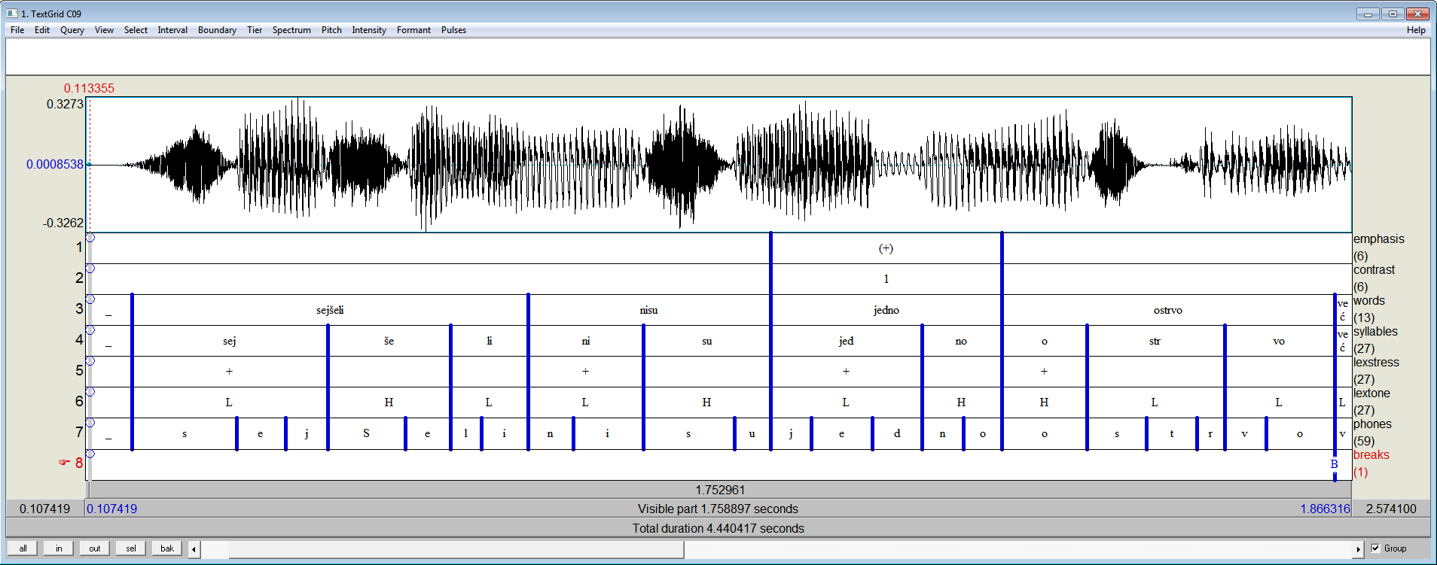
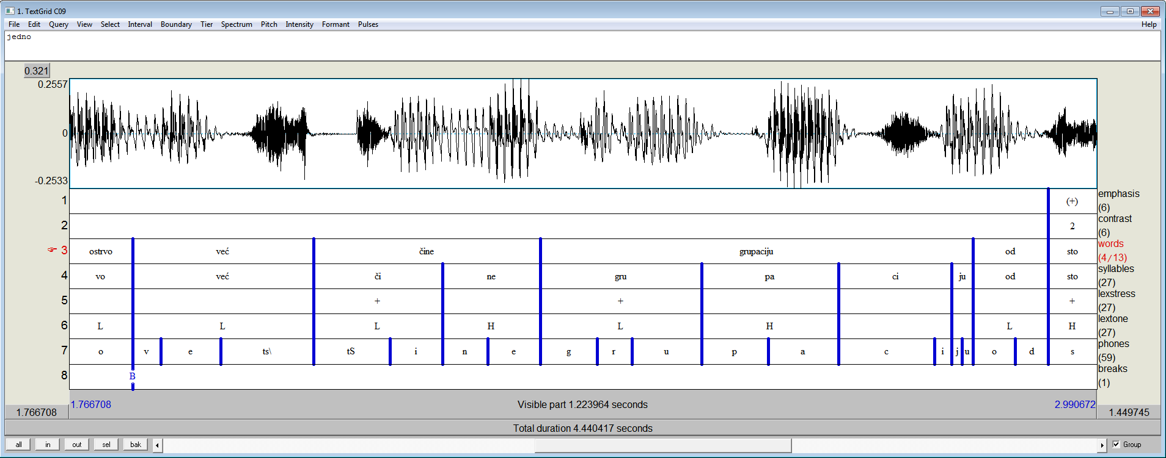
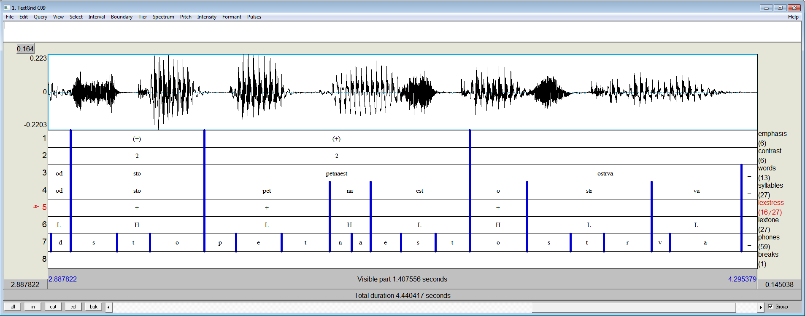
Figure 2. Annotation of a non-emphasized utterance in Serbian, where the absence of emphasis is indicated by ‘(+)’ on the emphasis tier, while the elements in semantic contrast are indicated by ‘(1)’ and ‘(2)’ respectively. Note that the timeframes in the three images slightly overlap.
The annotations should be stored as Praat TextGrid files, in a particular language folder and speaker subfolder in the SCOPES Corpus folder (an example of a path is SCOPES/Corpus/Audio/Macedonian/agjoreski/annotations). The annotations should have the same names as corresponding wavs (e.g. A01E.TextGrid).
Note that although most tiers are optional, some of them have to be annotated manually (such as Contrastive stress and Phrase breaks), while most others can be handled automatically, at a later stage (such as Phones).

3.4. Updating the phoneset
Each party should update the phoneset table SP2 PhoneSets.xls in the Corpus folder, by updating the column corresponding to the language in question. This column should contain the set of the phonemes of the corresponding language in SAMPA notation (regardless of whether a phoneme actually appears in the corpus). If a phoneme is not already in the table (if it is not listed in the IPA column), a new row should be added. Note that updating other columns is optional, i.e., it is not necessary to enter the phonological properties of each new phoneme.

Appendix
A | EMPHASIS ON ONE WORD
A01 | Everybody thought that he knew about the plot.
A02 | The room had to look disgusting.
A03 | In the Netherlands there are more bicycles than inhabitants.
A04 | But the one who has achieved the most was his youngest sister.
A05 | This process already happens at the first auditory level.
A06 | It turned out that it was a fake gun.
A07 | He himself received all the delivered furniture.
A08 | It looks that Serbia goes into recession again.
A09 | The damage caused by the earthquake is being estimated by forty teams.
A10 | Despite the popular belief, pets are not a substitute for children.
B | EMPHASIS EARLY ON IN THE SENTENCE
B01 | I will pay.
B02 | No data exists about how the funds are distributed
B03 | They requested it from us.
B04 | Finally I heard the news.
B05 | Money is what i like the most.
B06 | We had to ask strangers for help.
B07 | Heavy wind broke the window.
B08 | September is the hardest time for restaurants.
B09 | George told them about it.
B10 | Never would I tell him that.
C | CONTRASTIVE EMPHASIS
C01 | The plant was brought form South America although it didn’t originate there.
C02 | We not only suggested it but we also did it.
C03 | And thus our prices are European while our salaries are Bangladeshi.
C04 | Before the green one he drove her blue convertible.
C05 | Neither of them wants to play for Serbia but for Bosnia.
C06 | Instead of getting a rest, I got tired.
C07 | Since he cannot buy it, he’s going to rent it.
C08 | Thirty thousand Russians don’t want to go to Dalmatia but to Turkey.
C09 | Seychelles are not a single island but a group of one hundred and fifteen islands.
C10 | One does not remember numbers but human stories.
D | CONTRASTIVE EMPHASIS IN A QUESTION
D01 | Did he buy or borrow the book?
D02 | Are you emotional or rational?
D03 | Firstly, it is important whether you think like a woman or like a man.
D04 | Is it a date or you’re just hanging around?
D05 | Does sunbathing raise or lower the blood pressure?
D06 | Is it an innate female trait or she learned it unconsciously, looking at other females?
D07 | Many athletes wonder if it’s better to run before or after crunches.
D08 | When you look at that foul you wonder whether the referees didn’t see it or didn’t want to see it.
D09 | The question is whether you are allergic to sugar or you are just sugar intolerant.
D10 | Do you see stressful situations as opportunities for learning or you condemn yourself and assume the role of a victim?
E | EMPHASIS AS A RESULT OF A SEMANTIC FOCUS ON A RELATIVELY LARGE CONSTITUENT
E01 | It was because she felt so lonely that she decided to move.
E02 | She moved from Oxford to Cambridge, and not the other way round.
E03 | Only if you finish your homework will you be allowed to watch TV.
E04 | This British woman failed the theoretical driver’s test one hundred and ten times.
E05 | For doing the same thing we got kicked out of the amphitheater.
E06 | Only on the race track are we allowed to run.
E07 | Sam van Aken managed to grow a tree that bears forty different kinds of fruit.
E08 | In the movie “The Silence of the Lambs” Anthony Hopkins never blinked.
E09 | Pornography constitutes thirty seven percent of the entire contents of the Internet.
E10 | She learned to read back in the kindergarten without anyone’s help

